**QA Test Feedback**

**Date: 14th October, 2024**

**Time: 9:10am**

**QA Tester: Gabriel Ameh**

**WHAT DID WORK**

1. **Downloaded the app**

The app icon is not displaying

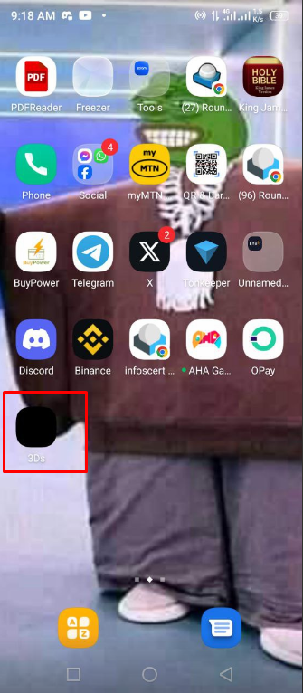

Feedback:– verdict: **DID NOT PASSED**

**2. Sign Up**

I was unable to signup, the error below pops up when clicked on signup button

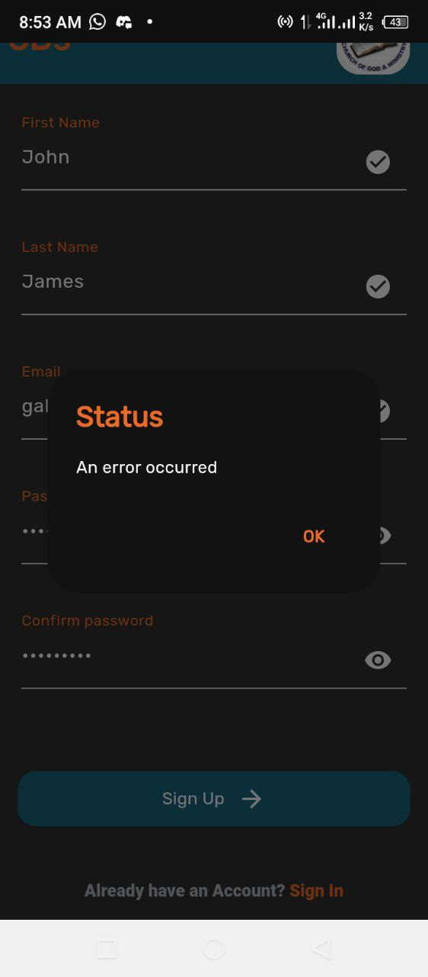

Feedback:– verdict: **DID NOT PASSED**

1. **User Login**

I could not login the error below pops up when the sign in button is clicked

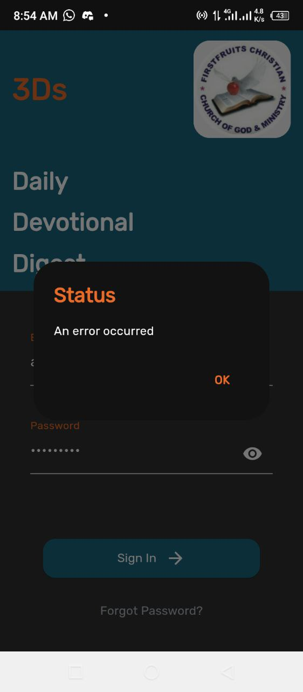

Feedback:– verdict: **DID NOT PASSED**